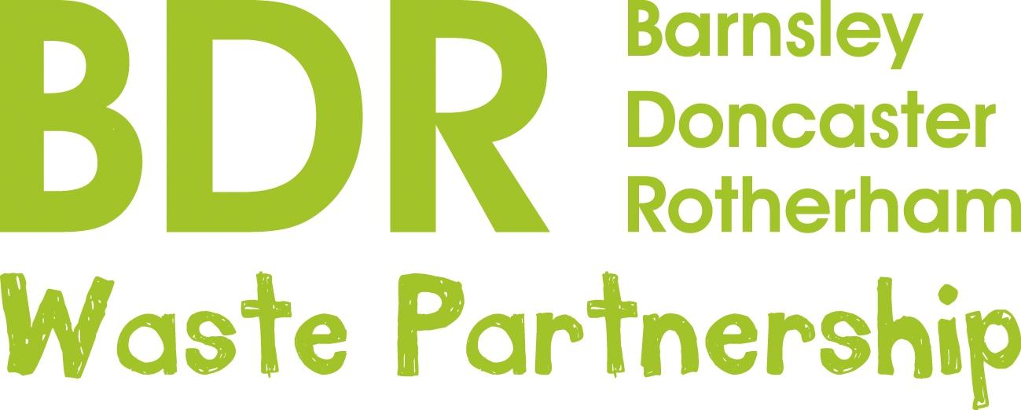

**P R E S S R E L E A S E**

**5th October, 2020**

**Choose to re-use while shopping**

Shopping trips are very different at the moment because of Covid – we have to think about masks, social distancing and hand sanitisers as well as what we are going to buy.

So it’s a good time to also think about how we might shop a bit differently in order to help save our precious planet.

Since the 5p charge was introduced, more than nine billion bags have been taken out of circulation, resulting in an estimated 50 per cent reduction in plastic bag marine litter.

If used once a week, four or five re-usable bags will replace 520 bags a year.

And buying loose fruit and veg cuts plastic packaging at home, reduces food waste by letting you buy just the quantity you need, and often saves money into the bargain.

Pop fruit and veg straight into a re-usable fabric bag which can be washed and used again and again. The bags have other uses too - they are ideal washing machines for delicate underwear and face-cleaning cloths. They can also be used to store small items like toys, sunglasses, leads and chargers when travelling.

Fabric face masks can be washed again and again, cutting down on the number of disposable masks which often contain plastic. Please dispose of these responsibly, conservationists have warned of disposable masks floating like jellyfish in our seas.

The re-use while shopping campaign is the latest in a monthly re-use campaign by the Barnsley, Doncaster and Rotherham (BDR) Waste Partnership and Renewi, the firm behind the waste treatment facility at Manvers.

Other targets have been clothing, plastic bottles, cutlery and straws, tea bags and carrier bags.

Community Education Liaison Officer, Abi Cox, who is based at Manvers, said cutting down on plastic when we shop can make a major difference.

“It’s a sobering thought that by 2050, the oceans could have more plastic than fish,” she said. “But individual actions add up and can make an enormous difference. If we all put the re-use reminder at the top of our shopping list, we can help reduce waste and make our planet a greener place to live and enjoy.”

**Note to Editors: The award-winning waste treatment facility at Manvers processes around a quarter of a million tonnes of leftover waste a year from 340,000 homes across Barnsley, Doncaster and Rotherham, turning it into useful products rather than sending it to landfill.**

**For further information contact Abi Cox or Rebecca Wilson on 07814 302297 or** [**abigail.cox@renewi.com**](mailto:abigail.cox@renewi.com) **or** [**rebecca.wilson@renewi.com**](mailto:rebecca.wilson@renewi.com)