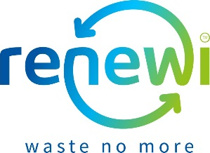
Renewi Corporate Social Responsibility Fund
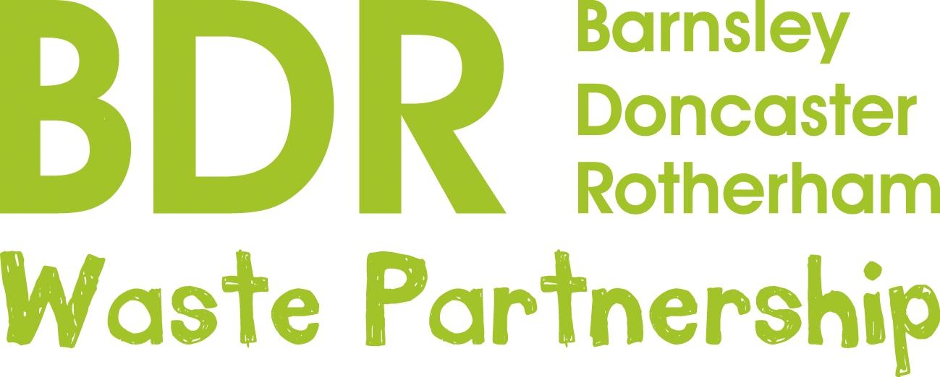
Application Form – 2020/2021

Please ensure that you have read the ‘Renewi Corporate Social Responsibility Fund Information Sheet’ prior to completion of this form.

Contact details
Named contact for organisation/group:
Role/position within organisation/group:
Name of organisation/group:
Contact phone number for named contact:
Contact email address for named contact:
Organisation/group street address:
Organisation/group website:
Organisation/group Facebook:
Organisation/group Twitter:

Your group

Please confirm that you are authorised to make an application on behalf of the organisation/group. (Mark with an X)
Yes

Please confirm that you are the property owner or have written consent from the owner for any work undertaken.
(Mark with an X)
Yes

Please briefly describe the remit of your organisation/group including examples of what you do and how often:

Please describe the typical audiences that your organisation/group works with. Please include numbers, ages, demographics etc:

Does your organisation/group have the following?
(Mark with an X)
A constitution
A bank account
Auditable accounts
None of these

Location
Which of the 5 geographic areas does your project fall within? Please select all those that apply.
Locations within 3.5 km (as the crow flies) of the Bolton Road waste treatment facility
Benefit of project reaches community within 3.5 km (as the crow flies) of the Bolton Road waste treatment facility
Barnsley Metropolitan Borough Council local authority area
Doncaster Metropolitan Borough Council local authority area
Rotherham Metropolitan Borough Council local authority area

Financial support
Do you wish to apply for financial support for your project?
(Mark with an X)
Yes, we are able to provide 10% match funding.
Yes, however we are not able to provide 10% match funding.
No we do not wish to apply for funding.

If yes, how much funding would you like to apply for? .......................
Is this application part of a larger funding application?
No, this is not part of a larger application.
Yes, this part of a larger application.
(IF YES) We are also applying to .................................................................. for £.......... and expect to know if we have been successful in this bid by ......................... .

Volunteer hours
Do you wish to apply for volunteer time for your project?
Yes, we are able to provide 50% match volunteer hours.
Yes, however we are not able to provide 50% match volunteer hours.
No we do not wish to apply for volunteer hours.

(IF YES), how many volunteer hours would you like to apply for? .......................

Your Project
Please provide some information about the project that you wish to undertake. Please be specific about your targets, how funding will be used and items purchased, the tasks to form part of the volunteer time, the benefits to your current audience, anticipated increases in activity or audience and any benefits to the wider community.

Please briefly outline the project that you wish to undertake:

Please briefly outline how any funding applied for will be used:

Please briefly outline how any volunteer hours applied for will be used:

Please briefly outline how the project will benefit your current audience:

Please briefly outline how this project will benefit the broader community:

If successful, would your organisation/group be happy to participate in PR activities such as photo shoots and press articles?
(Mark with an X)

Yes
No

Please can you tell us how you heard about Renewi Corporate Social Responsibility Fund
Thank you for your application.
Please return your application to Rebecca.Wilson@renewi.com or post to the address below
Rebecca Wilson,
BDR Waste Treatment Facility,
Bolton Road, Rotherham,
S63 7LL
Please ensure that your application arrives by the closing date.

