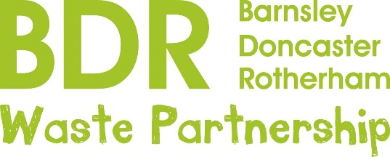

P R E S S R E L E A S E
26th May, 2020

Put the kettle on!
Britain loves a brew. Every day we drink around 100 million cups of tea and 70 million cups of coffee.
But our favourite drinks are damaging the environment because they create a lot of waste.
The problem is the latest to be tackled in a monthly campaign being run by the Barnsley, Doncaster and Rotherham (BDR) Waste Partnership and Renewi, the firm behind the award-winning waste treatment facility at Manvers.
Every Tuesday during each month a different item we all use or consume in every day life will come under the spotlight for its impact on the environment. In June it will be teabags and coffee pods.
Most cups of tea are made from teabags, which might look like paper and tea but are in fact damaging to the environment because they are sealed with plastic or bio-plastic and cannot be composted.
Switching to loose leaf tea and an infuser will help reduce waste and the used tea leaves can be added to your compost heap.
Nearly a third of all UK households now own an espresso pod coffee machine. Around 39,000 coffee pods are made every minute across the world, most of which will be thrown away without recycling.
Using an aluminium pod that can be returned to the shop for recycling, or re-usable pods that can be filled with just the right amount of coffee, the grinds composted and the pod re-used, will help reduce our waste.
Community Education Liaison Officer, Abi Cox, who is based at Manvers, said the small size of teabags and coffee pods meant their impact on the environment was often overlooked.
“They may be small but the sheer number used every day across the world and the fact that they can take up to 500 years to decompose means they are an environmental headache.
“Changing the way we make our tea and coffee means we can be kind to the environment without sacrificing the most important drink of the day.
“We know people in Barnsley, Doncaster and Rotherham do care about the environment and want to do their bit, and our monthly campaigns are aimed at helping them.
“We’ll be doing social media posts every Tuesday throughout the month under the hashtag #ChooseDayisReuseDay.”
Watch out for more re-use targets including plastic bottles, school clothing, cutlery and straws, loose fruit and vegetable bags, clothing, and face wipes and toiletries.
Note to Editors: The award-winning waste treatment facility at Manvers processes around a quarter of a million tonnes of leftover waste a year from 340,000 homes across Barnsley, Doncaster and Rotherham, turning it into useful products rather than sending it to landfill.
For further information contact Abi Cox or Rebecca Wilson on 07814 302297 or abigail.cox@renewi.com rebecca.wilson@renewi.com

